SCREENSHOTS

OUTPUT:

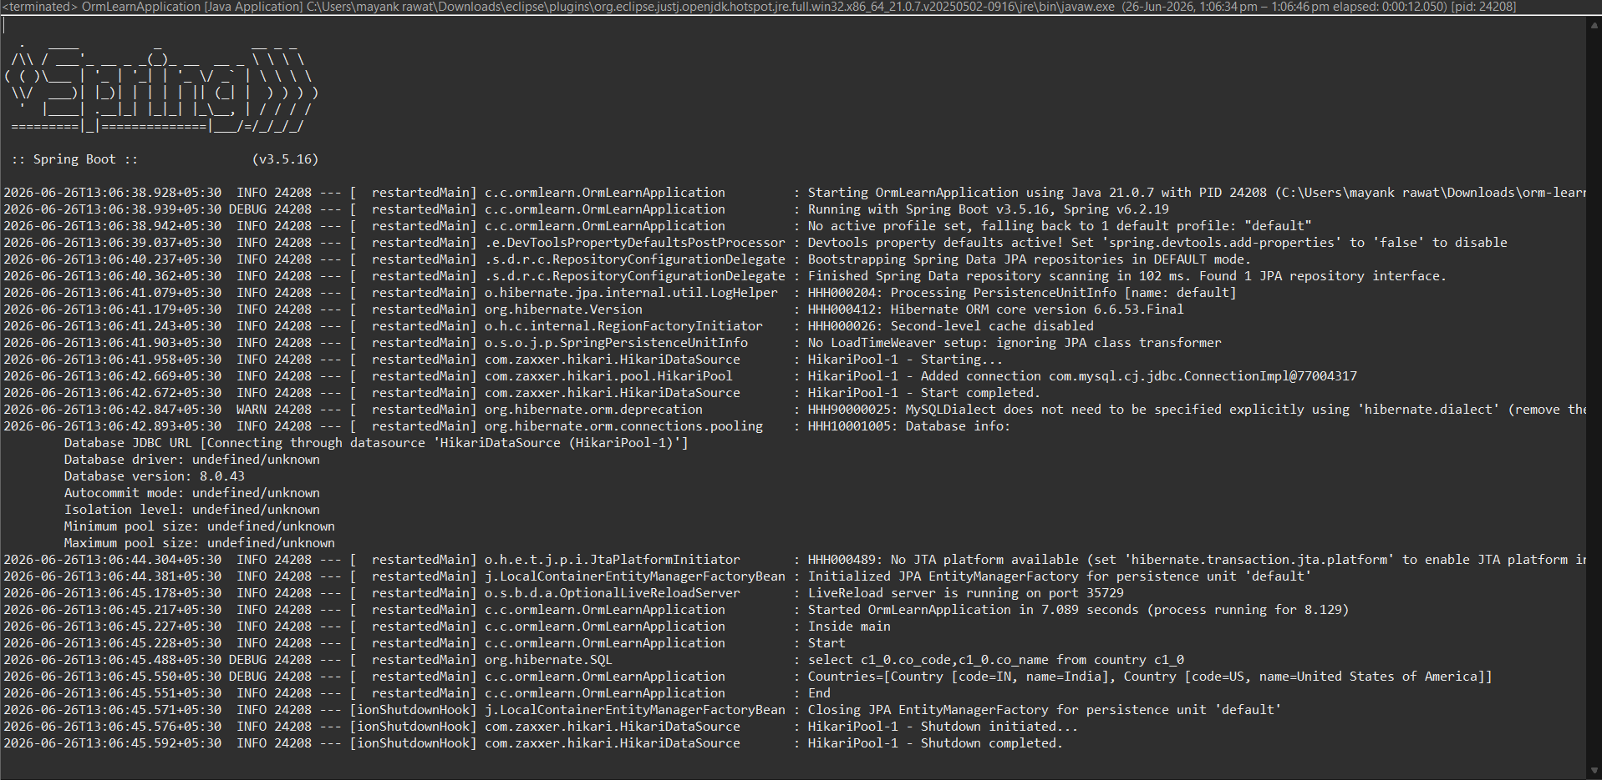
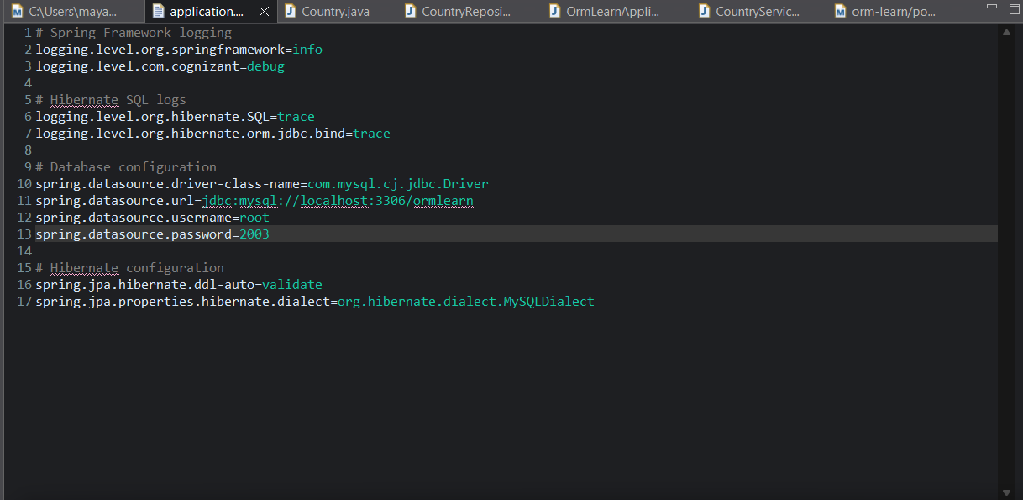
ApplicationProperties
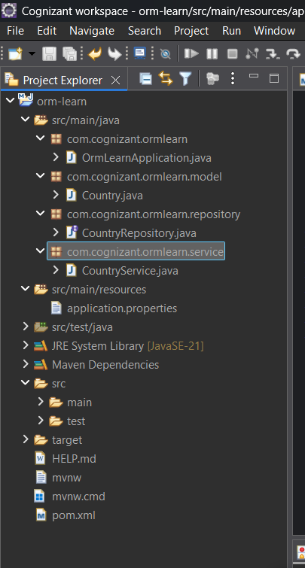
MySQL Workbench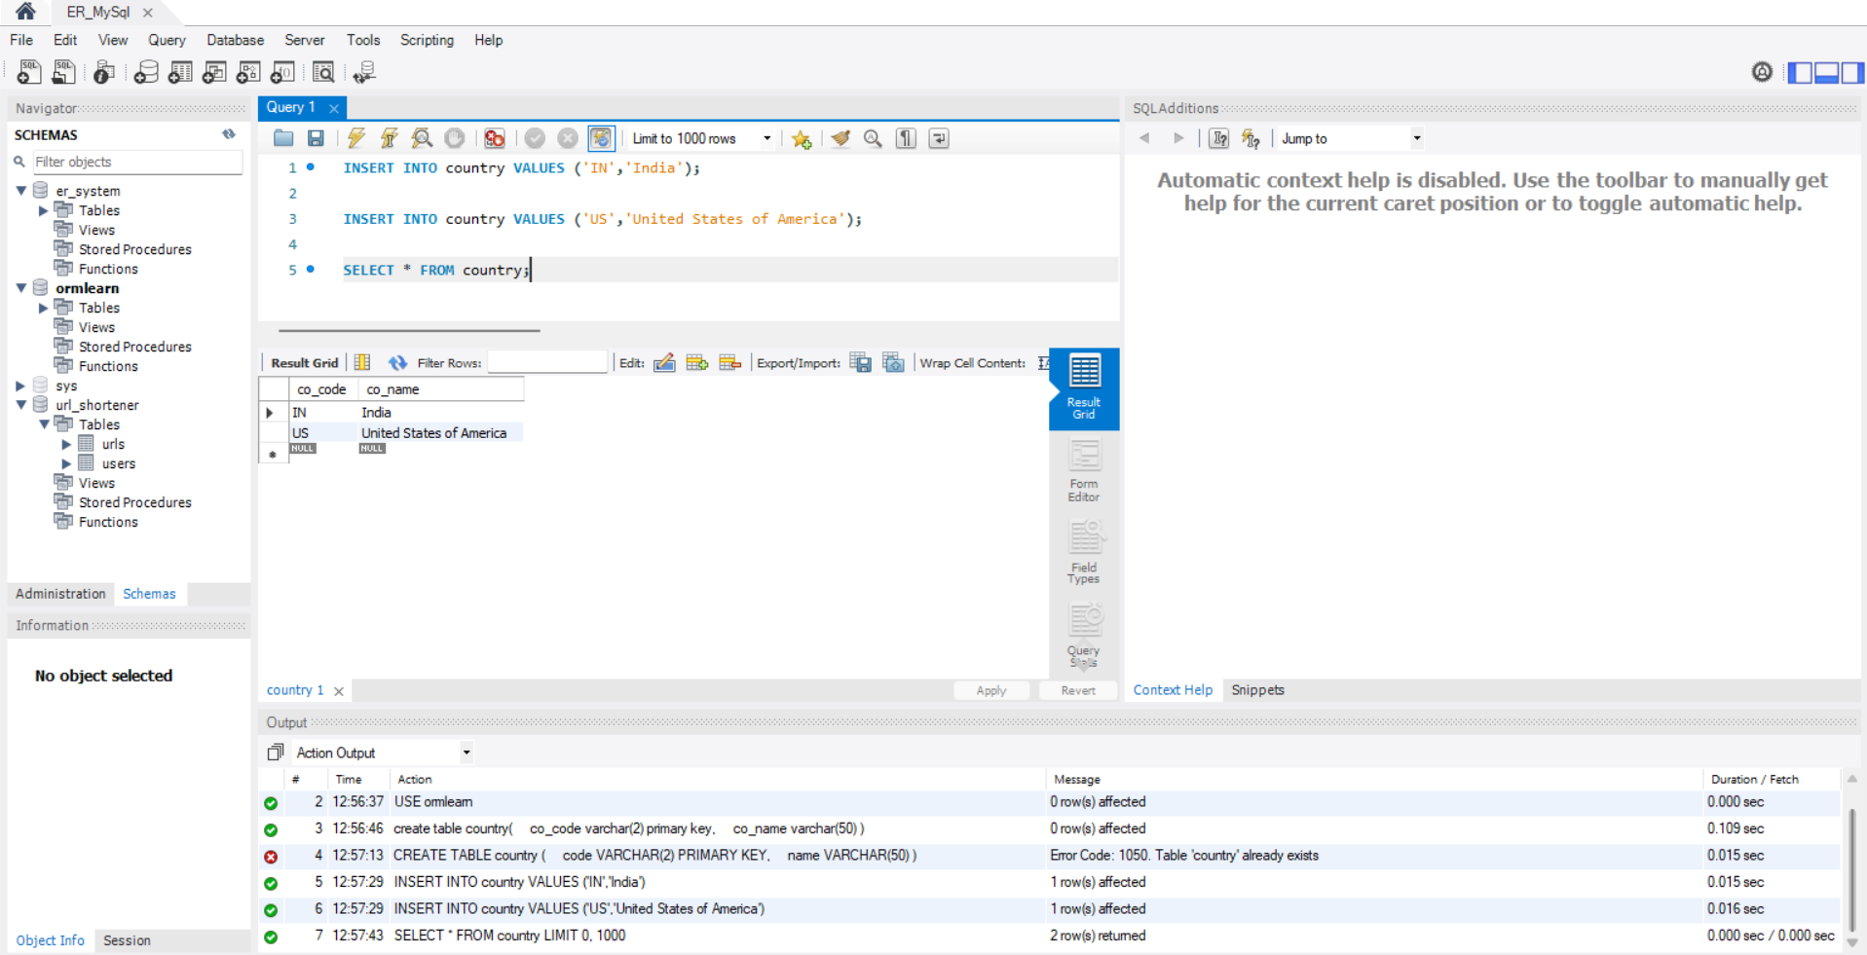

CODE:
OrmLearnApplication.java

package com.cognizant.ormlearn;

import java.util.List;
import org.slf4j.Logger;
import org.slf4j.LoggerFactory;
import org.springframework.boot.SpringApplication;
import org.springframework.boot.autoconfigure.SpringBootApplication;
import org.springframework.context.ApplicationContext;
import com.cognizant.ormlearn.model.Country;
import com.cognizant.ormlearn.service.CountryService;

@SpringBootApplication
public class OrmLearnApplication {
private static final Logger LOGGER = LoggerFactory.getLogger(OrmLearnApplication.class);
private static CountryService countryService;

public static void main(String[] args) {
ApplicationContext context = SpringApplication.run(OrmLearnApplication.class, args);
LOGGER.info("Inside main");
countryService = context.getBean(CountryService.class);
testGetAllCountries();
}

private static void testGetAllCountries() {
LOGGER.info("Start");
List<Country> countries = countryService.getAllCountries();
LOGGER.debug("Countries={}", countries);
LOGGER.info("End");
}
}

Country.java

package com.cognizant.ormlearn.model;

import jakarta.persistence.Column;
import jakarta.persistence.Entity;
import jakarta.persistence.Id;
import jakarta.persistence.Table;

@Entity
@Table(name = "country")
public class Country {
@Id
@Column(name = "co_code")
private String code;

@Column(name = "co_name")
private String name;

public Country() {}

public String getCode() {
return code;
}

public void setCode(String code) {
this.code = code;
}

public String getName() {
return name;
}

public void setName(String name) {
this.name = name;
}

@Override
public String toString() {
return "Country [code=" + code + ", name=" + name + "]";
}
}


CountryRepository.java

package com.cognizant.ormlearn.repository;

import org.springframework.data.jpa.repository.JpaRepository;
import org.springframework.stereotype.Repository;
import com.cognizant.ormlearn.model.Country;

@Repository
public interface CountryRepository extends JpaRepository<Country, String> {}


CountryService.java

package com.cognizant.ormlearn.service;

import java.util.List;
import org.springframework.beans.factory.annotation.Autowired;
import org.springframework.stereotype.Service;
import com.cognizant.ormlearn.model.Country;
import com.cognizant.ormlearn.repository.CountryRepository;
import jakarta.transaction.Transactional;

@Service
public class CountryService {
@Autowired
private CountryRepository countryRepository;

@Transactional
public List<Country> getAllCountries() {
return countryRepository.findAll();
}
}


